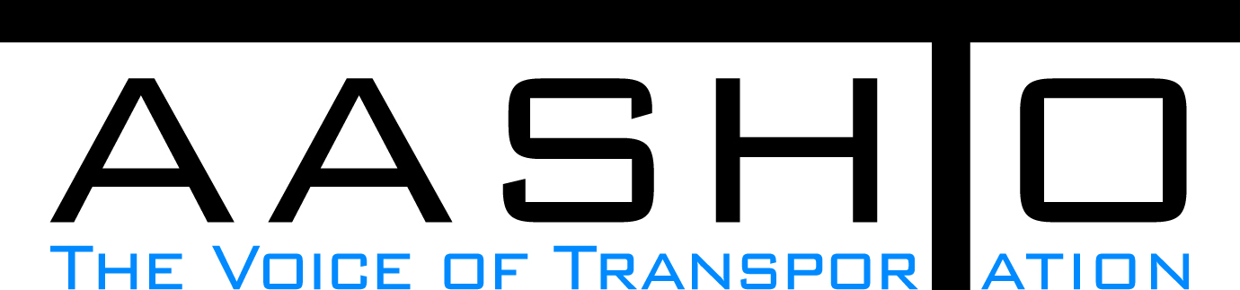Domestic Scan Proposal Form
AASHTO is soliciting topic proposals for a Calendar Year 2013 US Domestic Scan Program (NCHRP Panel 20-68A). Each selected scan topic will be investigated through site visits to three to six locations for approximately a two week period or less (type 1), by webinar (type 2) or peer exchange (type 3) conducted by a group of eight to 12 transportation professionals with expertise in the selected topic area. Proposed topics should meet the following criteria:
- Address an important and timely need for information by transportation agencies;
- Are of interest to a broad national spectrum of people and agencies;
- Are complex and also “hands-on,” meaning they lend themselves particularly well to exploration through on-site visits; and
- Are sufficiently focused that the tour participants are able to investigate and understand key issues in the limited time available on the tour.
This form is designed to collect the full length of your proposal. Sections requiring essays have unlimited space for you to use. Contact information has some limited text. Use your TAB key to advance to the area where you need to complete information.
Proposals should be returned no later than OCTOBER 15, 2012.
Proposal Contact Information
Name | Dean Perkins | Address | Florida DOT  Office of Design  605 Suwannee St., MS-40, Tallahassee, FL 32399-0450
Title | Ada Coordinator | E-mail | dean.perkins@dot.state.fl.us
Member Department | Florida DOT | Telephone number | 850-414-4359
AASHTO Committee | Design | Date of submission

Title of Proposed Scan

Compliance With The Americans With Disabilities Act (Ada)

Problem Statement (What topic is to be examined? What drives the need for the scan? Why now?)
The ADA has been effective for over 20 years (January 26, 1992). Many state and local government agencies are having a hard time determining to what extent public services and facilities must be "accessible to and useable by" persons with disabilities and how to prioritize various accessibility needs. US Department of Transportation, Federal Highway Administration (FHWA) has developed guidance and 'best practices' documents for transportation agencies to use in their compliance efforcts. However, many State Transportation Agencies (STAs) and local public works departments seem to be either unaware of this guidance, or they are unaware of how to put the recommendations into practice, leading to inconsistent compliance for transportation facilities around the country.

Scan Scope (What specific subject areas are to be examined? Which cities and states might be visited? Which agencies/organizations (including specific departments or types of staff if applicable)?
The Scan would include site visits to 'model' project locations that represent outstanding examples of compliance with the Americans with Disabilities Act (ADA). Visits would include discussions with agency personnel and reviews of documents. Sites to be visited would include pedestrian facilities within public rights of way: sidewalks, curb ramps, street crossings, pedestrian signals, etc. Documents to be reviewed would include: planning policies, design standards, construction manuals, inspection guidelines, agency ADA transition plans, and procedures for the development of transportation projects and facilities. Interviews would include staff involved in the development of the model projects visited and the policies and practices they used to ensure completion of successful projects. The Scan would include state and local government transportation departments that have well-developed policies, procedures and practices leading to compliance with the ADA Standards for Transportation Facilities and, where applicable, implementation of the proposed Accessibility Guidelines for Public Rights of Way. Anticipated agencies to visit include: Florida DOT, California DOT, Maryland State Highway Administration, Texas DOT, Washington State DOT, Miami-Dade Public Works and San Diego Public Works.

Anticipated Scan Results (What key information is to be gained? What information is to be shared after the scan? Who would the audience be for this information?)
The Scan would provide real-world, 'best practices' information for STAs implementing accessibility standards and guidelines. The Scan would include the types and nature of compliance activities: policies, procedures and standards developed to implement the ADA requirements. It would also include examples of documents and facilities illustrating reasonable and feasible methods used to comply. The Scan would provide information on the tangible and intangible resourses needed to provide improved access to transportation services and facilities. It is anticipated that the information would be shared with all state and local transportation agencies and public works departments and, possibly, risk-management departments.

Benefits Expected (Including potential impacts on current technology or procedures)
Benefits would include improved guidance for, and coordination of, state and local transportation agencies leading to a more uniform implementation of the ADA regulations and standards, and better accessibility to transportation services and facilities across the country. Also, we could expect more coordinated guidance to the requirements and expectations of the U.S. Department of Justice and the U.S. Department of Transportation. Including representives of the federal regulating agencies in the Scan could lead to more coordinated guidance from AASHTO, FHWA and other USDOT administrations: Federal Transit Administration (FTA), Federal Railway Administration (FRA), etc.

